

Ballari-Hosapete Road, Allipur, Ballari-583 104 (Karnataka) (India) Ph:08392 – 237100 / 237190, Fax: 08392 – 237197

DEPARTMENT OF
ARTIFICIAL INTELLIGENCE AND MACHINE LEARNING
A

Mini Project Report On

“HridAmṛit”

Submitted By
SHREE DARSHAN MANVIKAR 3BR23AI146
SIRI CHANDANA P KATTI 3BR23AI150
SRIVIDHYA ALAPATI 3BR23AI154
SRINIDHI G 3BR23AI155

Under the Guidance of Dr. Mallikarjuna A Professor/Asst HOD

Dept of AIML, BITM, Ballari

Visvesvaraya Technological University

Belagavi, Karnataka
2025-2026

Ballari-Hosapete Road, Allipur, Ballari-583 104 (Karnataka) Ph:08392 – 237100 / 237190, Fax: 08392 – 237197
(India)

DEPARTMENT OF
ARTIFICIAL INTELLIGENCE AND MACHINE LEARNING

CERTIFICATE

Certified that the project work entitled “HridAmṛit: Your AI-Powered Heart Guardian for Prediction & Protection” carried out by Mr.Shree Darshan Manvikar, Ms. Siri Chandana P Katti, Ms. Srividhya Alapati, Ms. Srinidhi G bearing USN 3BR23AI146, 3BR23AI150, 3BR23AI154, 3BR23AI155, are bonafide students of Ballari Institute of Technology and Management in partial fulfillment for the award of Bachelor of Engineering in Artificial Intelligence and Machine Learning of the Visvesvaraya Technological University, Belgaum during the year 2025- 2026. It is certified that all corrections/suggestions indicated for Internal Assessment have been incorporated in the Report deposited in the departmental library. The project report has been approved as it satisfies the academic requirements in respect of the project work prescribed for the said Degree.

Signature Guide | Signature of HOD | Signature of Coordinator | Signature of Principal
Dr. Mallikarjuna A | Dr. B. M. Vidyavathi | Srinath V Devale | Dr. Yadavalli Basavaraj

ABSTRACT
HridAmṛta is an AI-powered heart-attack risk prediction system designed to assist individuals in understanding their cardiovascular health through early-stage risk assessment. Cardiovascular diseases remain a leading cause of mortality worldwide, primarily due to delayed diagnosis and lack of awareness of early warning signs. HridAmṛta addresses this challenge by utilizing machine learning techniques to predict heart-attack risk based on user-provided health parameters such as age, blood pressure, cholesterol, glucose levels, BMI, lifestyle habits, and medical indicators.The system employs a LightGBM classification model, chosen for its high accuracy, efficiency, and capability to handle tabular medical data. A user-friendly web interface built with React.js allows easy data entry and displays outcomes in a clear, interpretable manner. The Flask backend securely processes inputs, performs the prediction, and provides personalized recommendations. High-risk users receive alert notifications, enabling them to take timely preventive measures.
By combining machine learning, secure data handling, and intuitive design, HridAmṛta serves as a preventive healthcare assistant that promotes early risk awareness and encourages proactive health management. While not intended to replace medical diagnosis, the system supports individuals in making informed health decisions and recognizes the growing importance of AI in modern healthcare applications.

ACKNOWLEDGEMENT
The satisfaction that accompanies the successful completion of project work on “HridAmṛit: Your AI-Powered Heart Guardian for Prediction & Protection” would be incomplete without the mention of people who made it possible, whose noble gesture, affection, guidance, encouragement, and support crowned our efforts with success. It is our privilege to express our gratitude and respect to all those who inspired us in the completion of this project work.
We are extremely grateful to our respective guide Dr. Mallikarjuna A, for his noble gesture, support, coordination and valuable suggestions given to us in completing the project work. We also thank Dr. B M Vidyavathi, H.O.D. Department of AIML, for her coordination and valuable suggestions given to us in completing the project. We also thank the Principal, Management, and non-teaching staff for their coordination and valuable suggestions given to us in completing the project work.

Name USN
Shree Darshan Manvikar 3BR23AI146
Siri Chandana P Katti 3BR23AI150
Srividhya Alapati 3BR23AI154
Srinidhi G 3BR23AI155

TABLE OF CONTENTS
S No. Chapter Page No.

Abstract | I
Acknowledge | II
1 Introduction | 1
2 Literature Survey | 2-3
3 Problem Statement | 4
4 Objectives | 5
5 Methodology | 6-8
6 Requirements | 9
5.1 Functional Requirements | 9
5.2 Non-Functional Requirements | 9
7 Design | 10
7.1 Use Case Diagram | 10-11
7.2 Activity Diagram | 12-13
7.3 Class Diagram  7.4 Sequence Diagram | 14-15  16
8 Implementation | 17
8.1 Modules | 17
8.2 Module Description | 17
8.2.1 User Authentication Module | 17
8.2.2 User Data Input Handling Module | 17
8.2.3 Data Pre processing Module | 18
8.2.4 Machine Learning Model Module | 18
8.2.5 Prediction and Risk Evaluation Module | 18
8.2.6 Recommendation and Precaution Module | 18
8.2.7 Alert and Notification Module | 19
8.2.8 Frontend Interface Module | 19
8.2.9 Backend Service Module | 19
8.2.10 Integration and testing module | 19
8.3 Tools used | 20
8.3.1 Programming languages | 20
8.3.2 Technologies libraries and frameworks | 21-23

- Test cases 24
  - Unit Testing 24-26
- Result and Discussions 27-30
- Advantages and Disadvantages 31
  - Advantages 31
  - Disadvantages 31
- Applications 32
- Conclusion 33
References 34

LIST OF FIGURES

Figure Number | Figure Name | Page No
5.1 | Methodology | 5
7.1 | Use Case Diagram | 10
7.2 | Activity Diagram | 13
7.3 | Class Diagram | 15
7.4 | Sequence Diagram | 16
10.1 | Home Page | 27
10.2 | Login Page | 27
10.3 | Signup Page | 28
10.4 | Manual Input | 28
10.5 Prediction 29
10.6 Precautions 29
10.7 Recommendations 30
10.8 Alert System 30

CHAPTER 1 INTRODUTION

CHAPTER 1

INTRODUCTION

Cardiovascular diseases (CVDs) are among the leading causes of death globally, accounting for millions of lives each year. One of the major challenges in preventing heart attacks is the lack of early detection and awareness of personal risk factors. Many individuals remain unaware of their cardiovascular health status until severe symptoms arise. With advancements in artificial intelligence and data-driven healthcare, it has become possible to assess potential risks earlier and more accurately[2][7].
HridAmṛta is an AI-powered heart-risk prediction system designed to assist individuals in understanding their likelihood of experiencing a heart attack based on key health indicators. The system uses machine learning techniques to analyze parameters such as age, blood pressure, cholesterol, glucose levels, BMI, and lifestyle habits including smoking and alcohol consumption. By processing these inputs, the system predicts the user's heart-attack risk category and provides personalized recommendations [1].
The platform is built using a React.js frontend, which offers a clean and interactive interface, and a Flask backend, which handles secure authentication, data processing, and integration with the LightGBM model. The system ensures user privacy through password hashing and structured data flow. When a high-risk prediction is detected, the system triggers alerts and displays precautionary measures that can help users take timely action [4].
HridAmṛta aims to promote preventive healthcare by encouraging users to monitor their cardiovascular health proactively. While the system is not a substitute for professional medical diagnosis, it serves as an accessible tool for early awareness, lifestyle improvement, and informed decision-making. With the increasing role of AI in healthcare, HridAmṛta demonstrates how technology can support individuals in managing their well-being more effectively [8].

CHAPTER 2

LITERATURE SURVEY

In Paper [1], titled "Effective Heart Disease Prediction using ML Techniques" by Chintan M Bhatt (Feb 2023), the authors focus on leveraging machine learning approaches for heart disease prediction. The study utilized a large Kaggle dataset containing 70,000 patient samples and employed advanced data preprocessing techniques including data cleaning and patient clustering using k-modes algorithm. The authors applied ensemble methods—specifically Random Forest (RF) and XGBoost—to capture complex relationships in cardiovascular health data, demonstrating improved prediction performance. The study showcases the potential of combining clustering with ensemble models to enhance disease prediction accuracy on large-scale datasets.

In Paper [2], titled "Enhancing Heart Attack Prediction with Machine Learning" by Alshraideh et al. (Mar 2024), the authors present a hospital-based approach to heart disease prediction using feature selection and classical machine learning models. Working with a hospital dataset containing 1,000 patient records, the research applies Random Forest (RF) and Support Vector Machine (SVM) models for disease classification. While the study demonstrates effective local predictions, the authors acknowledge critical limitations—the model was evaluated on data from a single hospital and requires validation across larger, more geographically diverse patient populations. Additionally, the work considers only limited health features and lacks real clinical deployment testing, highlighting the gap between research models and practical clinical application.

In Paper [3], titled "Heart Disease Prediction using ML & Explainable AI" by El-Sofany et al. (Oct 2024), the authors introduce explainable artificial intelligence (XAI) into cardiovascular disease prediction. The research combines private and public patient datasets (503 records total) with careful feature engineering to identify key health indicators. The authors apply multiple machine learning models—SVM, XGBoost, and Random Forest—with emphasis on model interpretability. A significant contribution of this work is addressing the "black-box" problem in medical AI by providing transparent insights into prediction mechanisms, which is critical for clinical acceptance and patient trust.

In Paper[4], titled "Stacked Ensemble Optimized ML for Heart Disease" by Ashika et al. (Jun 2025), the authors advance the field by employing stacked ensemble learning architectures that combine multiple base learners including XGBoost, Random Forest, and SVM. The research analyzes diverse datasets to improve generalization across different patient populations. However, the authors note that while ensemble methods enhance accuracy, the models remain largely tested on public benchmark datasets without comprehensive real-world validation. The work identifies the critical need for real-time deployment frameworks and continuous monitoring systems to transition from batch predictions to live patient monitoring scenarios.

CHAPTER 3

PROBLEM STATEMENT

To Design and develop an AI-driven system that takes manual inputs to predict heart attack risks. This system will provide personalized prevention recommendations and send emergency alerts to reduce fatal events, monitoring and individualized intervention, addressing a critical gap in heart attack management.

CHAPTER 4

OBJECTIVES

- To predict individual heart attack risk by analyzing health history.
- To explain key risk factors and root causes in accessible language, delivering actionable insights.
- To recommend daily habits customized to each user’s risk profile with measurable impact.
- To alert users and doctors in high-risk situations to enable timely intervention.

CHAPTER 5

METHODOLOGY

The methodology for the HridAmṛta project follows a structured approach to accurately predict cardiovascular risk and provide precaution, recommendation, and alert support based on user-entered health information. The overall process is divided into several stages, from data collection and preprocessing to model training, deployment, and user interaction through the web application as shown in the figure 5.1.

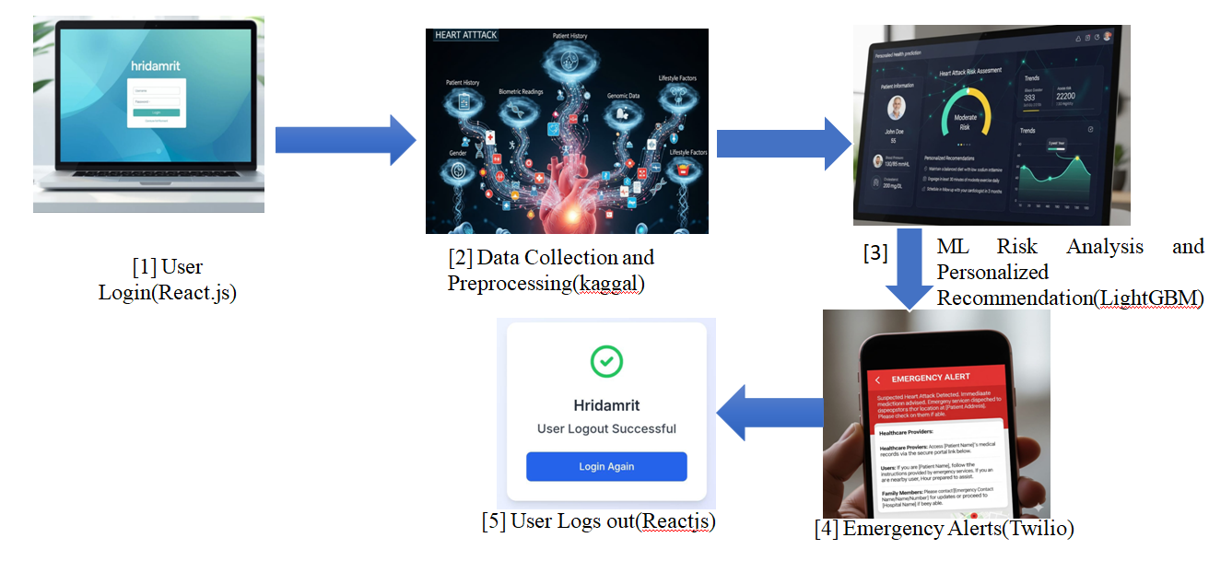

Figure 5.1 Methodology

Training Data

The foundation of the prediction system is a high-quality, labeled dataset related to heart disease risk. For this project, publicly available cardiovascular/heart disease datasets are collected, containing clinical and lifestyle attributes along with a target label indicating the presence or absence of heart disease.
The data typically includes attributes such as age, gender, blood pressure, cholesterol levels, resting ECG findings, fasting blood sugar, chest pain type, exercise-induced angina, maximum heart rate, and other medically relevant factors used as input features for the model

Processing Data

Once the raw dataset is collected, it is processed to make it suitable for input into the machine learning model. This stage includes several steps:

Data Cleaning: Handling missing values, correcting inconsistent entries, and removing obvious outliers that may degrade model performance.

Feature Engineering: Creating or transforming features (for example, BMI from height and weight, risk categories from continuous variables) and encoding categorical variables into numerical form.

Data Normalization/Scaling: Standardizing or scaling numeric attributes so that no single feature dominates the learning process and gradient-based algorithms train more efficiently.

Train–Test Split: Dividing the dataset into training and testing subsets to objectively evaluate model performance on unseen data.

Processed Data

After preprocessing, the final structured dataset is ready for model training. It consists of:

Input Features: Cleaned and transformed clinical and lifestyle attributes representing each user’s heart health profile.

Target Label: A binary or multi-class outcome indicating heart disease presence, risk level, or probability score, which the model learns to predict.

Machine Learning Model

At this stage, a Machine Learning model is trained on the processed data to learn patterns between risk factors and cardiovascular outcomes. In HridAmṛta, gradient-boosting–based algorithms such as LightGBM or similar tree-based models are employed because they handle mixed feature types well and provide string predictive performance on tabular medical data.

Web Application and User Input

The trained model is integrated into a web-based application built using a backend framework (such as Flask) and a suitable frontend interface. Users interact with the system by manually entering their health and lifestyle details into a structured input form, matching the features used during model training.

Prediction , Precaution , Recommendation , Alert

Based on the model’s output, the system classifies the user into appropriate risk categories such as low, moderate, or high risk. For each category, predefined precaution messages and personalized recommendations are generated, guiding the user on lifestyle changes, follow-up tests, or medical consultation needs.

If the predicted risk crosses a defined threshold, the system triggers an alert message within the application (and optionally through email/SMS if configured), emphasizing urgency and suggesting immediate medical attention. This closes the loop from prediction to actionable prevention, which is the core objective of the HridAmṛta platform.

CHAPTER 6

REQUIREMENTS

Functional Requirements
- User Data Input: The system shall allow users to manually enter their personal, clinical, and lifestyle details through a secure and user-friendly interface.
- Heart-attack Risk Prediction: The system shall process the entered data using a trained machine learning model to generate a heart-attack risk score or category for the user.
- Alerts and Notifications: The system shall display appropriate alerts and notification messages to users, especially when a high or critical heart-attack risk is detected.

Non-Functional Requirements
- Performance: The system should respond quickly and handle multiple user requests efficiently while maintaining accurate predictions.
- Security: The system should protect user data through secure transmission, storage, and controlled access to prevent unauthorized use.
- Usability: The system should provide a simple, intuitive interface so users can easily enter data, understand results, and navigate features without confusion..

CHAPTER 7

DESIGN
The Design consists of a use case diagram, sequence diagram, activity diagram, and class diagram as follows.

Use Case Diagram
A Use Case Diagram is a visual tool used to capture the functional behavior of a system from the perspective of external actors. It identifies the users of the system, the major services (use cases) they perform, and the boundaries of the application.
In the HridAmṛta system, the primary actors are the User and the Admin. The User performs use cases such as “User sign up/login,” “Enter manual input,” “Heart-attack prediction,” and “View recommendations & precautions,” which together support end-to-end risk assessment. The Admin is associated with use cases like monitoring predictions, reviewing generated alerts, and managing or updating recommendation rules, ensuring that clinical logic and thresholds remain appropriate over time as shown in figure 7.1.
Common components include:
- Actors: External entities (User, Admin) that interact with the web application and either supply data or consume prediction results.
- System Boundary: The HridAmṛta application that hosts all use cases related to authentication, data entry, prediction, recommendation, and alerting.
- Goals: To provide a simple way for users to log in, submit health details, obtain accurate risk predictions, receive clear guidance, and allow admins to supervise alert behavior and recommendation quality.

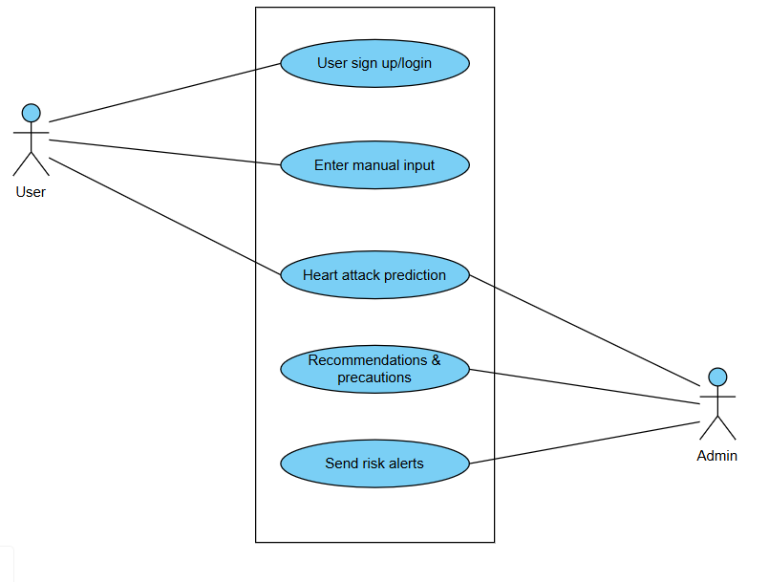 Figure 7.1 Use Case Diagram

7.2 Activity Diagram
An Activity Diagram represents the dynamic workflow of the system by showing activities, decisions and the order in which they occur. It is particularly useful for understanding the business process and identifying critical decision points.
For HridAmṛta, the activity flow begins with the user entering an email address and password. A decision node checks if the credentials are valid; invalid credentials lead to a “Prompt for re-entry” activity and a loop that continues until no input attempts remain, in which case the session terminates. When the login is successful, the user proceeds to “Select major function,” chooses heart-attack prediction, and then performs “Enter manual data,” where clinical and lifestyle attributes are captured. The next activity is “Predict heart-attack risk,” after which a decision evaluates whether the risk is high. If the risk is high, the system performs “Send risk alert” followed by “Provide precautions,” emphasizing immediate actions. If the risk is not high, the control flows to “Provide recommendations,” presenting lifestyle modifications or follow-up advice, and finally the process ends as shown in figure 7.2.
The Activity Diagram clarifies:
- The sequential nature of authentication, input, prediction, and response.
- Where validation and branching occur (login decision, high-risk decision).
- How alerts, recommendations and precautions are triggered based on the predicted risk category.

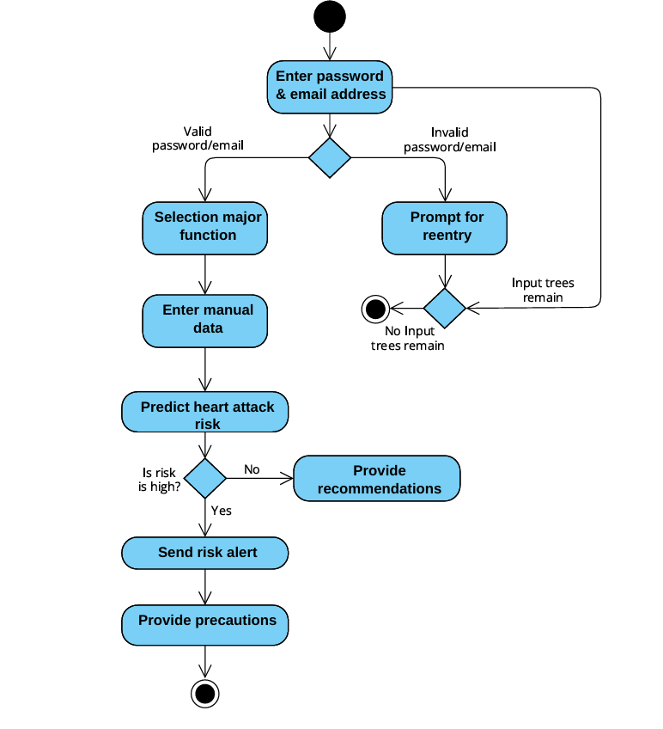

Figure 7.2 Activity Diagram

7.3 Class Diagram
A Class Diagram describes the static structure of the software by detailing classes, their attributes, operations and relationships. It is used to plan how data and logic are organized in the codebase.
In the HridAmṛta design, the User class holds attributes such as userId, name, email, passwordHashing, age and gender, with operations like login(), signup() and enterManualData(). Each User is associated with one or more HealthData instances, which store fields such as dataId, heartRate, bloodPressure, cholesterol, glucose, and timestamp—representing the manual health inputs collected from the user as shown in figure 7.3.
The PredictionModel class contains modelId, modelName and accuracy, and exposes the method predictRisk(HealthData) that returns a numeric risk score. This score is encapsulated by the RiskReport class, which records reportId, riskLevel and riskScore and provides generateReport() to summarize the outcome. The RecommendationsSystem class maintains recId, a list of recommendations and precautions, and offers generateRecommendations() to map a given risk level to tailored advice. Finally, the AlertManager class, with attributes alertId, alertMessage and alertTime, provides sendAlert() to issue notifications when the RiskReport indicates a high-risk state.
Associations and dependencies between these classes show that User objects own HealthData, HealthData is consumed by PredictionModel, PredictionModel generates RiskReport, which in turn triggers RecommendationsSystem and AlertManager, forming a complete prediction-to-response pipeline

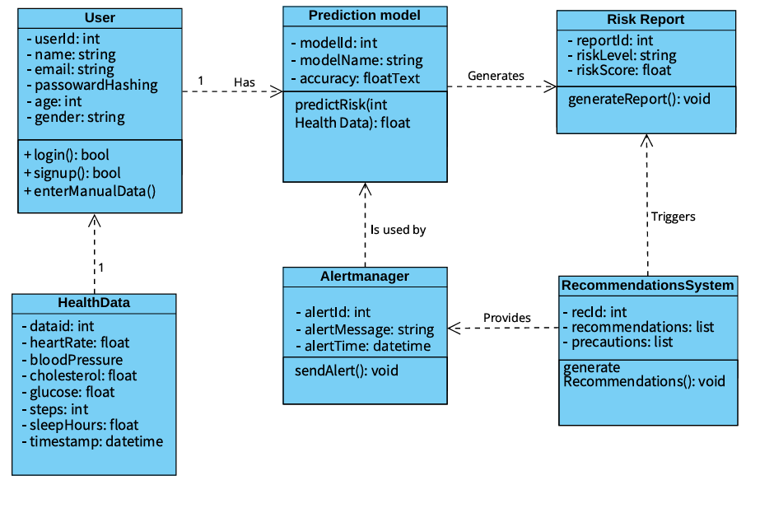

Figure 7.3 Class Diagram

Sequence Diagram:

A Sequence Diagram captures how objects interact over time by exchanging messages in a specific order. It is useful for validating that components collaborate correctly to execute a use case.
In the HridAmṛta system, the sequence for manual prediction starts with the User initiating a POST request to login, which is received by the Flask backend. Flask validates credentials and returns the login response. The user then submits manual health data via another POST request; Flask validates and packages this data and sends a “Invoke predict() with user input” message to the ML model (LightGBM) component. The model computes the risk score and returns “Predicted risk” to Flask. Flask then applies the business logic to determine the risk level, queries the recommendation and alert modules internally, and finally sends a consolidated response back to the User containing the prediction result, relevant precautions, personalized recommendations and any generated alerts.
This diagram emphasizes lifelines for User, Flask and ML model, synchronous calls for login and prediction requests, and the back-and-forth flow of messages required to complete a single prediction session, ensuring that all necessary steps—from data submission to display of actionable information—are performed in the correct temporal sequence as shown in figure 7.4..

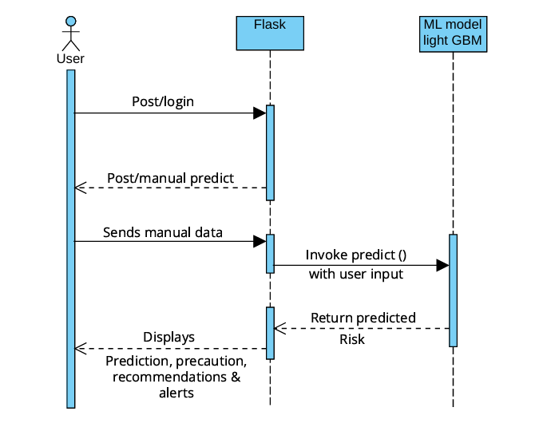

Figure 7.4 Sequence Diagram

CHAPTER 8

8.1 Modules

IMPLEMENTATION

- User Authentication Module
- User Data Input Handling Module
- Data Pre-processing Module
- Machine Learning Model Module
- Prediction and Risk Evaluation Module
- Recommendation and Precaution Module
- Alert and Notification Module
- Frontend Interface Module
- Backend Service Module
- Integration and Testing Module

8. 2 Module Description

User Authentication Module
This module provides secure access to the Hridamṛta system by handling user registration and login. It verifies credentials, manages user sessions, and ensures that only authenticated users can submit health data and view prediction results, thereby protecting sensitive personal information.

User Data Input Handling Module
This module manages the collection and validation of manually entered health and lifestyle details such as age, blood pressure, cholesterol and habits. It checks for missing or invalid values, enforces input formats and ranges, and converts the data into a structured format that can be passed to the pre-processing pipeline.

Data Pre-Processing Module

The data pre-processing module prepares user inputs so they are consistent with the format used during model training. It applies steps such as type conversion, encoding of categorical variables, normalization or scaling of numeric attributes, and feature construction when required (for example, computing BMI). This module ensures that every prediction request reaches the model as a clean, standardized feature vector.

Machine Learning Model Module
This module encapsulates the trained LightGBM (or similar gradient-boosting) model used for heart-attack risk prediction. It loads the serialized model file, maintains configuration such as feature order, and exposes a prediction interface to the backend. The module is responsible for efficient inference and can be updated independently when a retrained model is available.

Prediction and Risk Evaluation Module
The prediction module receives the processed feature vector from the pre-processing stage and forwards it to the ML model to obtain a probability or risk score. It then interprets this score using predefined thresholds to classify the user into categories such as Low, Moderate or High risk. The resulting values are packaged into a structured response object that downstream modules can use.

Recommendation and Precaution Module
This module maps the evaluated risk level to appropriate health advice. For each category, it generates a set of recommendations (for example lifestyle changes, follow-up tests) and specific precautions to reduce the chance of a heart event. The content is stored in configurable rule sets so that domain experts can refine the recommendations without changing core code.

Alert and Notification Module
The alert module is triggered whenever the predicted risk crosses a configured threshold. It prepares concise alert messages summarizing the risk status and key precautions, and returns them to the frontend for display. If extended channels such as email or SMS are integrated, this module is responsible for formatting and dispatching those notifications.

Frontend Interface Module
Implemented using HTML, CSS and a lightweight framework (such as Streamlit or a Flask-rendered UI), this module presents forms for login and manual data entry and pages for displaying prediction results. It focuses on clear layout, error prompts for invalid inputs, and readable visualization of risk level, recommendations and alerts so that non-technical users can easily understand the output.

Backend Service Module
The backend module, built with Flask, coordinates all server-side logic. It defines REST endpoints for authentication, data submission and prediction, orchestrates calls to the pre-processing, model, recommendation and alert modules, and returns JSON responses to the frontend. It also logs requests and errors to support monitoring and debugging.
8.2.10 Integration and Testing Module
This module combines all components into a single deployable system and ensures reliability through systematic testing. It covers unit tests for individual functions, integration tests for API flows from input to prediction to response, and user-acceptance testing to confirm that the interface behavior, messages and results meet project requirements and are understandable to end user

Tools Used

Programming Languages

Python:

Python is a high-level, interpreted programming language widely used for its simplicity, readability and rich ecosystem of libraries. In this project, Python is used for backend development with Flask, data pre-processing, machine learning model training and inference, and automation scripts such as evaluation and logging. Its extensive standard library and third-party packages make it a versatile and powerful choice for integrating all components of the Hridamṛta heart-attack risk prediction system into a cohesive application.

Technologies, Libraries, And Frameworks

Technologies

Frontend:

React.js : For creating an interactive, responsive, and user-friendly interface to collect health parameters and display prediction results.

Backend:
      - Python: Core programming language used for data processing, model integration, and server-side logic.
      - Flask Framework: Lightweight backend framework used to build REST APIs, handle prediction requests, manage authentication, and communicate with the ML model.
      - Werkzeug Security: Used for hashing and verifying passwords to ensure secure user authentication.

Machine Learning Model Environment:
- LightGBM: High-performance gradient boosting model used for heart-risk prediction due to its speed, accuracy, and efficiency with tabular medical data.
- Kaggle Notebook: Used during experimentation and training of the model, allowing easy visualization, preprocessing, and evaluation.

Deployment:
- Node.js + React Scripts : Used for running and building the frontend development environment.
- Python Virtual Environment : Helps isolate project dependencies for backend and ML integration.

Libraries

Data Processing and Manipulation:
  - Pandas: For handling and manipulating molecular datasets.
  - NumPy: For efficient numerical computations.

Machine Learning:

LightGBM:Core library used for training and deploying the heart-risk prediction model.

Scikit-learn:Used for preprocessing, splitting datasets, performance evaluation, and building auxiliary ML components.

Backend & API Development:
  - Flask:
For creating REST API endpoints, routing, and connecting frontend requests with ML output.
  - Flask-CORS:
For enabling secure cross-origin communication between React (frontend) and Flask (backend).

Security & Authentication:

Werkzeug.security : Provides hashing and password-checking utilities ensuring secure storage of user credentials.

Visualization:

Matplotlib & Seaborn : For analyzing dataset distributions, correlations, and model performance during development.

Algorithms
- Gradient Boosting (LightGBM):
- Ensemble-based boosting technique that iteratively reduces prediction errors.
- Optimized for structured and tabular health data.
- Provides high performance with lower computational cost, ideal for medical-type datasets.

IDE :-
VS Code:

VS Code is a free, open-source code editor developed by Microsoft. It is used in this projectfor writing and managing the codebase. VS Code's wide array of extensions, integrated terminal, debugging tools, and support for numerous programming languages make it an ideal choice for developing and maintaining the project.

CHAPTER 9

TEST CASES

System testing is the stage of implementation, which is aimed at ensuring that the system works accurately and efficiently before live operation commences. Testing is the process of executing the program with the intent of finding errors and missing operations and also a complete verification to determine whether the objectives are met and the user requirements are satisfied.

Unit Testing :-

Test ID | Test Scenario | Input | Expected Outcome | Pass/ Fail
1.1 | Enter full name | Empty field /left blank | Display message ” please enter your name” | Pass
1.2 | Enter mail | Invalid email format (e.g., abc@ com) | Display message ” Enter  a valid email address’ | Pass
1.3 | Enter phone number | Invalid number(less than 10 digits) | Display message “Enter valid phone number” | Pass
1.4 | Enter password | Empty or too short password | Display message “Password must be at least 6 characters” | Pass
1.5 | All details valid | Correct full name, email phone ,password | Registration successful, redirected to login | Pass
2.1 | Enter data fields | Leave any health field empty | Display message “Please fill all details” | Pass

Test ID | Test Scenario | Input | Expected Outcome | Pass/ Fail
2.2 | Valid input details | Enter all valid values (Age, BP, Cholesterol, etc.) | “Get Prediction” button enabled | Pass
2.3 | Click “Get Prediction” | Submit filled data | Display prediction result with risk percentage | Pass
3.1 | View results | Submit valid data | Shows “Low / High Risk” result | Pass
3.2 | View precautions | Click “View Precautions” | Displays preventive measures page | Pass
3.3 | View recommendations | Click “Get Recommendations” | Displays personalized lifestyle and diet advice | Pass
4.1 | Set up alerts | Click “Set Up Alerts” | Opens SMS alert configuration page | Pass
4.2 | Enter phone number | Invalid or empty number | Display “Enter valid phone number” | Pass
4.3 | High-risk prediction | Model predicts high risk | SMS alert sent to user | Pass
5.1 | Open precautions | Click on “View Precautions” | Displays India-specific heart health preventive tips | Pass

Test ID | Test Scenario | Input | Expected Outcome | Pass/ Fail
5.2 | Open recommendations | Click on “View Recommendations” | Displays personalized health and diet goals | Pass
5.3 | Mark goal complete | Click “Mark as Complete” | Goal updates progress bar | Pass

CHAPTER 10
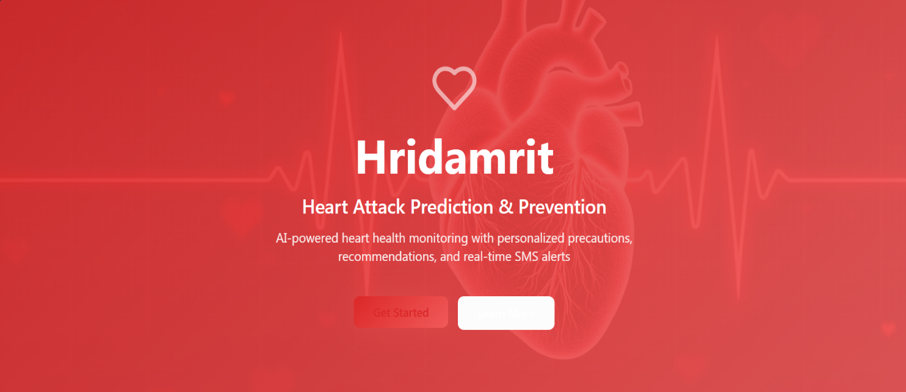

RESULTS AND DISCUSSION

Figure 10.1 Home Page

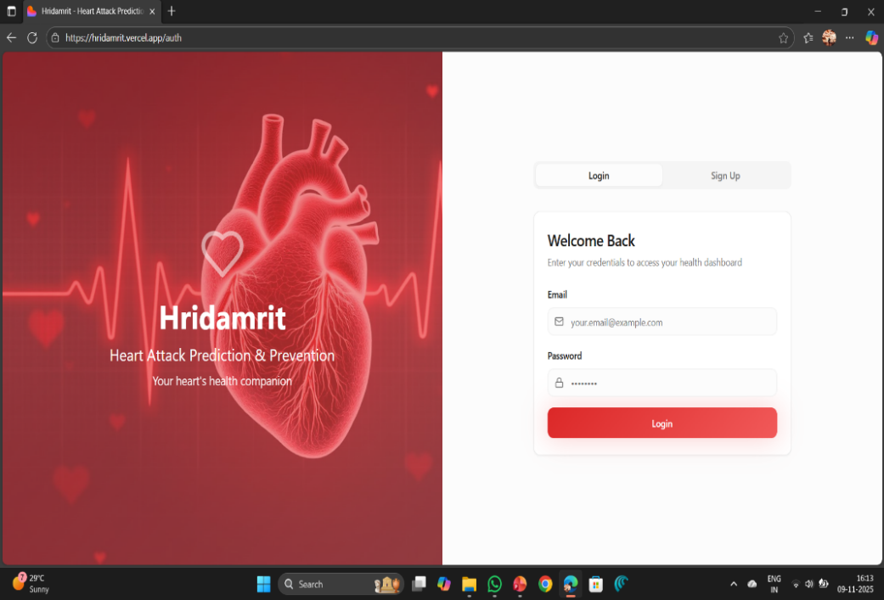
Figure 10.2: Login page

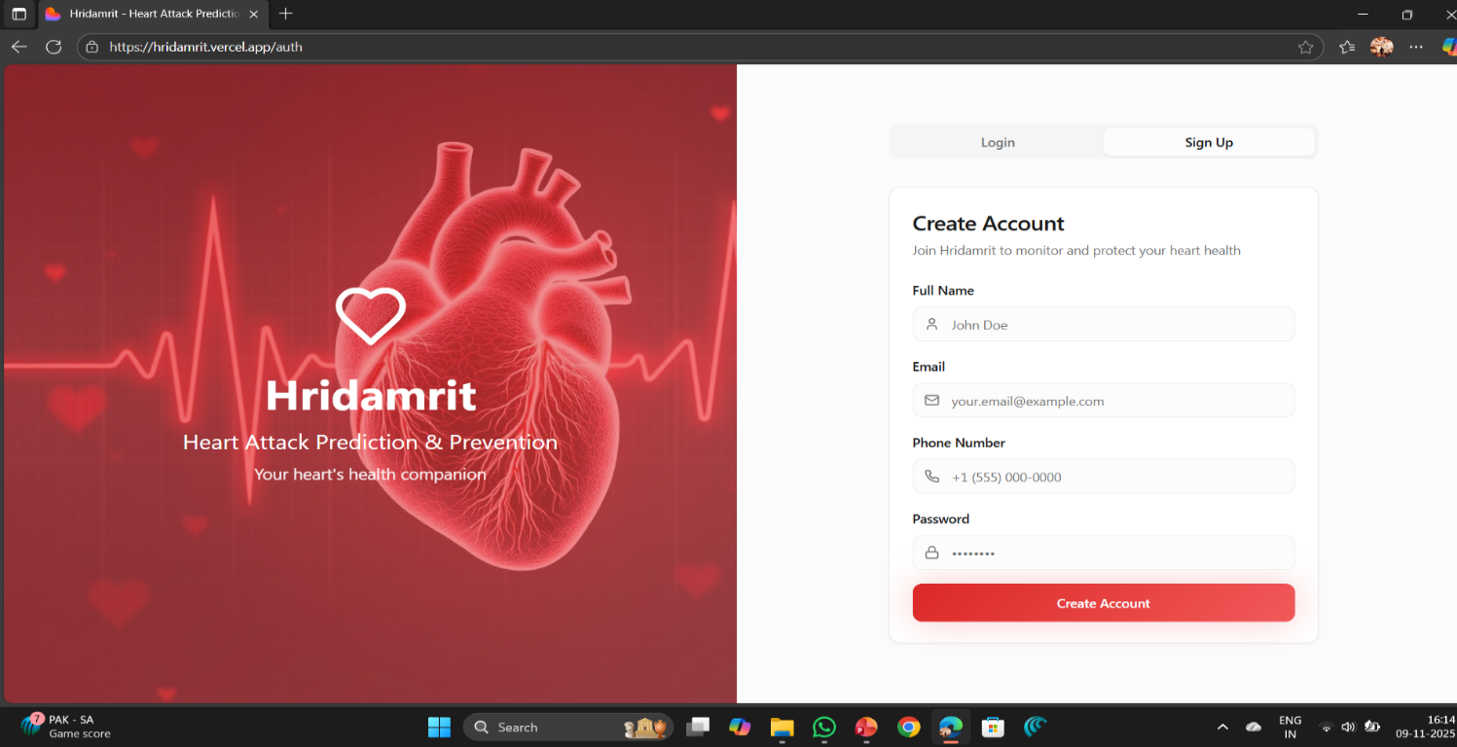
Figure 10.3: SignUp page
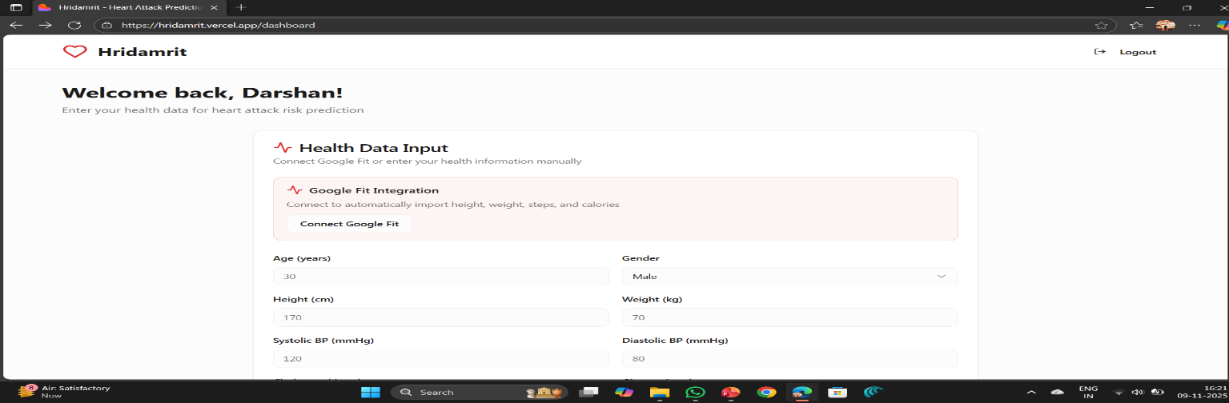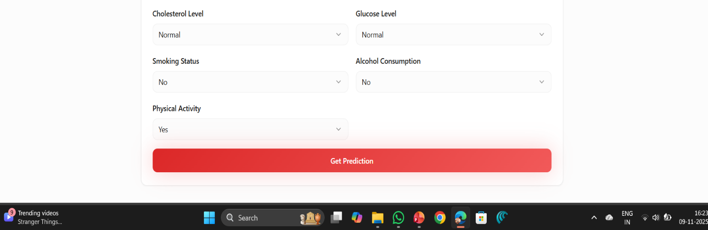
Figure 10.4: Manual input

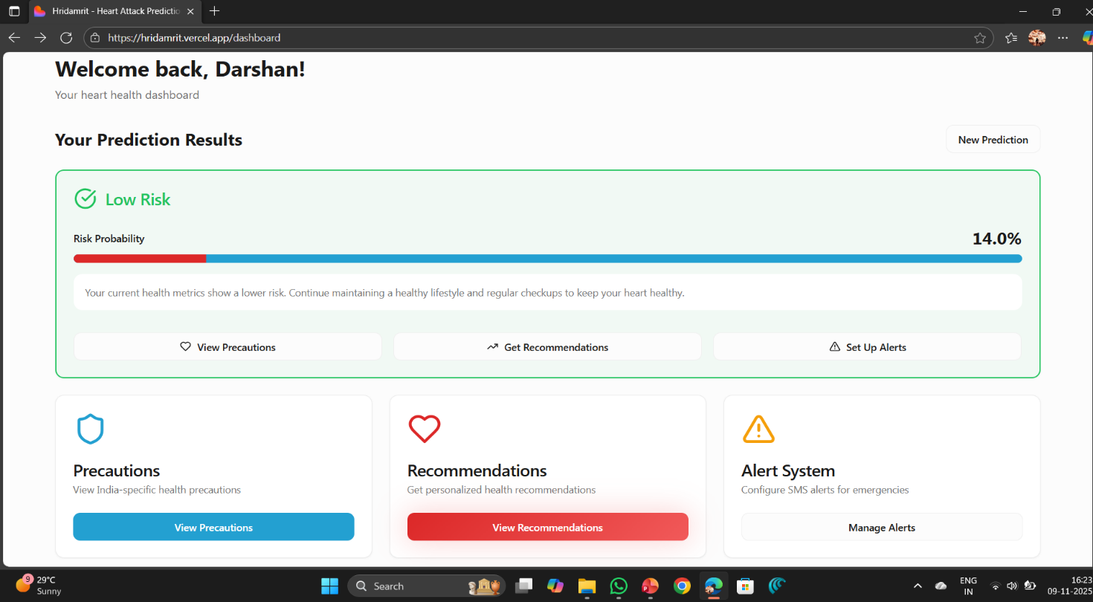

Figure 10.5: prediction

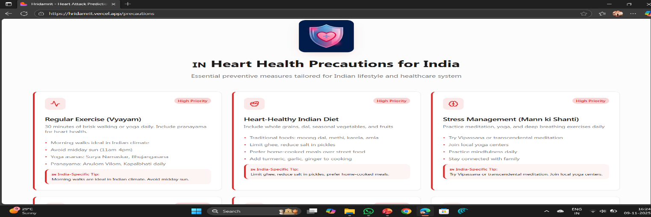
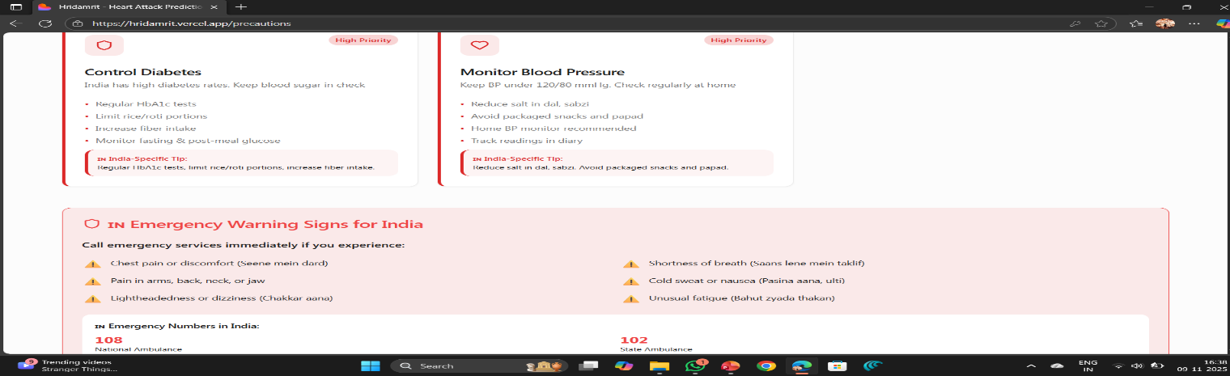

Figure 10.6: precautions

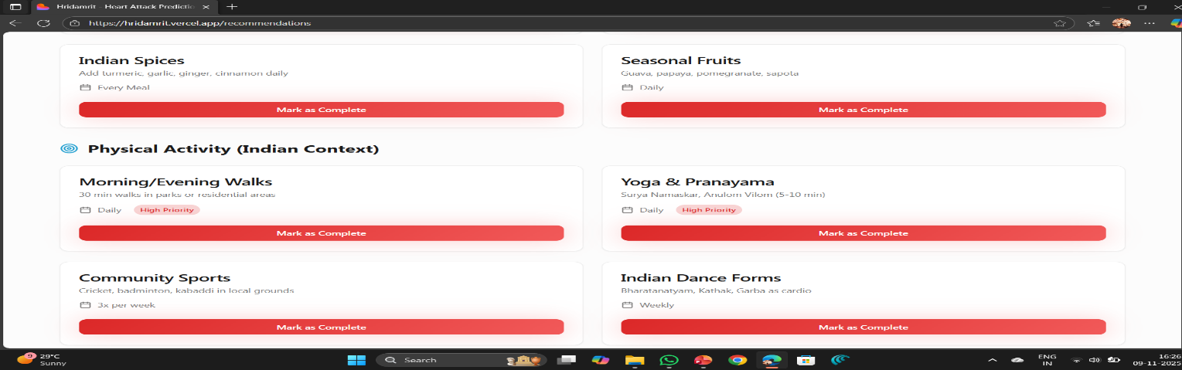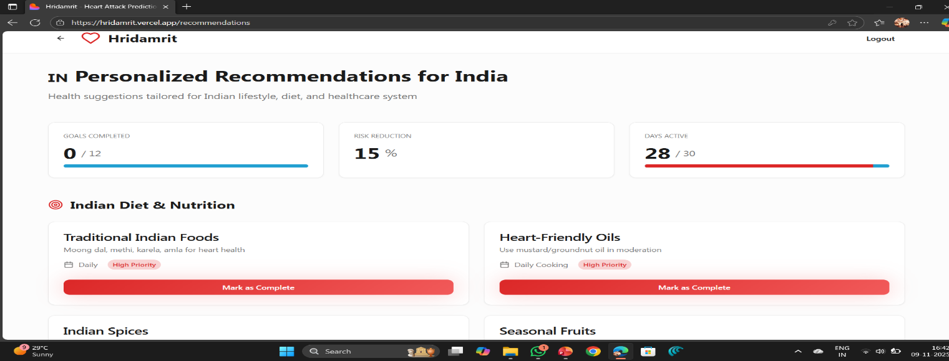
Figure 10.7: Recommendation
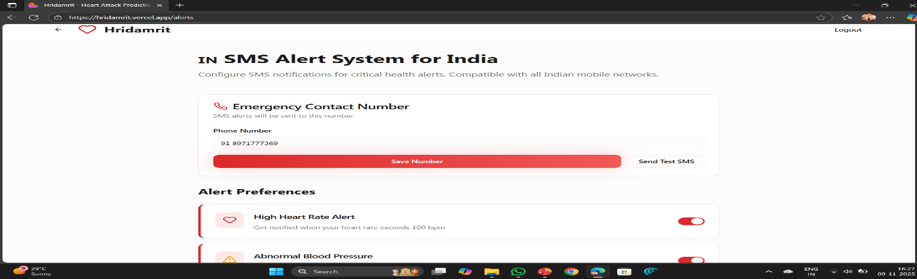
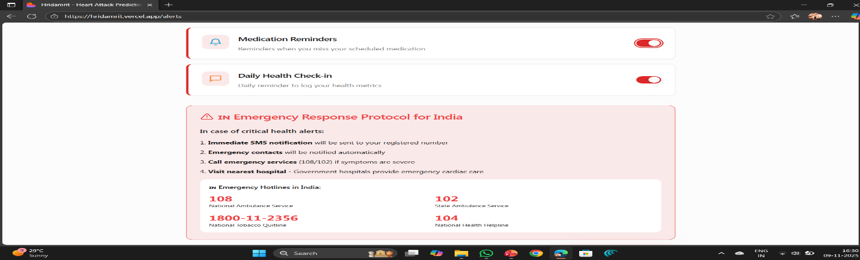
Figure 10.8: Alert System

CHAPTER 11 :-

ADVANTAGES AND DISADVANTAGES

Advantages:-
- ML-based Heart Risk Prediction:Provides accurate prediction by analyzing health parameters using advanced machine learning algorithms.
- User-Friendly Interface:Offers a simple and intuitive design that allows users to easily enter data and view results.
- Early Prevention and Recommendations:Helps users take timely action by providing personalized health suggestions based on risk level.
- Ensures Quick and Efficient Results:Processes inputs rapidly through optimized backend and ML model to deliver instant predictions.

Disadvantages:-

- Requires internet connection for prediction.
- Does not replace professional medical diagnosis.

CHAPTER 12 :-

APPLICATIONS

Hospitals & Clinics: Patient monitoring and early risk alerts for timely medical intervention.

Wearable & Fitness Industry: Integration with smartwatches and fitness trackers to add predictive intelligence.

Home Healthcare: Elderly and high-risk patients can be monitored remotely, reducing hospital visits

Insurance Sector: Risk-based premium evaluation and preventive healthcare programs.

Telemedicine Platforms: Enhanced remote consultations with patient health data.

CHAPTER 13 :-

CONCLUSION

Hridamrit makes heart health monitoring simple and accessible through ML-powered prediction. It helps users understand their heart risk instantly and provides easy-to-follow precautions and recommendations. The system also sends SMS alerts for high-risk cases, ensuring quick awareness and safety. By combining technology with healthcare, Hridamrit encourages people to take charge of their heart health and live a healthier life.

REFERENCES
- C. M. Bhatt, P. Patel, T. Ghetia, and P. L. Mazzeo, “Effective heart disease prediction using machine learning techniques,” Algorithms, vol. 16, no. 2, p. 88, Feb. 2023, doi: 10.3390/a16020088.
- M. Alshraideh et al., “Enhancing heart attack prediction with machine learning: A study at Jordan University Hospital,” Applied Computational Intelligence and Soft Computing, vol. 2024, pp. 1–16, Mar. 2024, doi: 10.1155/2024/5080332.
- H. El-Sofany, B. Bouallegue, and Y. M. Abd El-Latif, “A proposed technique for predicting heart disease using machine learning algorithms and an explainable AI method,” Scientific Reports, vol. 14, no. 23277, Oct. 2024, doi: 10.1038/s41598-024-74656-2.
- A. Ashika, S. Kumar, and T. Singh, “Stacked ensemble optimized machine learning for heart disease prediction,” International Journal of Medical Informatics, vol. 148, p. 104414, 2025, doi: 10.1016/j.ijmedinf.2025.104414.
- I. Sommerville, Software Engineering, 9th ed. Boston, MA, USA: Addison-Wesley, 2010.
- R. S. Pressman, Software Engineering: A Practitioner’s Approach, 7th ed. New York, NY, USA: McGraw-Hill, 2010.
- World Health Organization, “Cardiovascular Diseases (CVDs),” WHO Regional Office for Africa. Available: https://www.afro.who.int/health-topics/cardiovascular-diseases. Accessed: May 5, 2023.
- Z. Alom et al., “Early Stage Detection of Heart Failure Using Machine Learning Techniques,” in Proc. Int. Conf. Big Data, IoT, and Machine Learning, Cox’s Bazar, Bangladesh, Sep. 23–25, 2021.
- S. Gour, P. Panwar, D. Dwivedi, and C. Mali, “A machine learning approach for heart attack prediction,” in Intelligent Sustainable Systems, A. K. Nagar, D. S. Jat, G. Marín-Raventós, and D. K. Mishra, Eds. Singapore: Springer, 2022, pp. 741–747. doi: 10.1007/978-981-16-6309-3_70.
- C. Gupta, A. Saha, N. S. Reddy, and U. D. Acharya, “Cardiac Disease Prediction using Supervised Machine Learning Techniques,” J. Phys.: Conf. Ser., vol. 2161, p. 012013, 2022.

